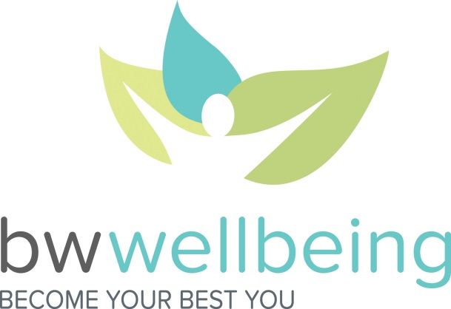

Frequently Asked Questions:
NEW Vitality Website
January 2016

Basics
- When did the new website go live? January 1, 2016!

- Where can I find…

My personal info? | Your Account (the gear icon in the top right-hand corner of the page) > Settings
Goals? | Health Profile > Goals
Forms I need to submit various activities? | Your Account (gear icon in the top right-hand corner of the page) > Forms and Waivers
Vitality Squares? | Rewards
HealthyFood? | Rewards OR Manage Your Links on the Vitality homepage
More information about the Vitality site? | Learning Center > Guide to Vitality

- What is the best way to understand my points? Under Points, you will find Points Planner and Points Statement. The Points Planner is NEW and meant to help you understand points both earned and available to you in each Vitality category. As you earn points within a category, your Points Available will decrease, and the green progress bar will advance. Once you have earned all available points in a category, that category “card” will display stars and a badge congratulating you on your achievement!

Vitality Goals
- It seems that goals work differently in the new website. Can you help me understand the change? While things look very different, much remains the same:
  - Vitality suggests goals for you based on your Vitality Health Review and Vitality Check (biometric screening)
  - You set the goal/s most meaningful to you
  - You have the same number of points available to you for reaching goals

The main differences are as follows:
- Rather than Vitality setting start and end dates for you, you choose the timeline for each of your goals
- You earn goal points differently. Rather than earning your points once a goal is complete, you may earn up to 30 points each week for “checking in” on your goal/s. This is meant to help you stay more connected to the goals you’ve set for yourself, as well as to reward you along the way.

For more information about Vitality Goals, go to Health Profile > Goals > Learn more about setting goals.

- Will the goals suggested by Vitality come along with recommended point-earning activities? Recommended point-earning activities will no longer be attached to goals; instead, you will find similar recommendations under Health Profile > Health Results. Click on any “card” on this page to see your Recommended Resources.

- Can I access my goals from the Vitality Today mobile app? Yes!

- Is there a goal “check-in window”? Yes – a new week starts each Monday at 12:01 am. You can check in on your goals at any time between Monday at 12:01 am and the following Monday at 12:00 am.

- Wait! I was working toward a goal on the old website. Did I lose all of my work toward that goal? No! Any goals-in-progress from the old website will be presented to you in the form of a message in the Message Center (envelope icon in the top right-hand corner of the page). Read your message for details on completing your goal, as well as related links or resources.

Miscellaneous
- I used to use a function called Healthy Habit Workouts. Where did this go?
Vitality has replaced Healthy Habit Workouts with the Self-Reported Workout Tool, which functions slightly differently. With the launch of the new website, you will no longer get “double credit” by recording 5,000+ steps on your device or checking into the gym and then also logging a Healthy Habit Workout the same day. Which we must admit never made much sense .

Instead, the Self-Reported Workout Tool is designed for those who do not own a fitness device, do not belong to a gym, or need the reasonable alternative standard. To access the tool, go to Your Account (the gear icon in the top right-hand corner of the page) > Forms and Waivers > Self-Reported Workout. For each Self-Reported Workout submitted, you will earn 5 points. These points count toward Workout Milestones as well as toward the Physical Activity category maximum.

Bottom line: You can earn points for one workout per day, and your highest-activity-level workout is the one that will stick. For instance, if you submit a Self-Reported Workout (5 points), check in at your gym (10 points), and log 15,000 steps on your Fitbit (15 points) the same day, you will be awarded 15 points for your steps.

Additional Questions?
Contact Vitality Customer Care at 1-877-224-7117 or wellness@powerofvitality.com.

